**Creating skills and assistant for Chatbot**

**Chatbot Skills Creation**

|  |  |
| --- | --- |
| Date | 10 November 2022 |
| Team ID | PNT2022TMID51074 |
| Project Name | AI Based Discourse for Banking Industry |

**Greetings**

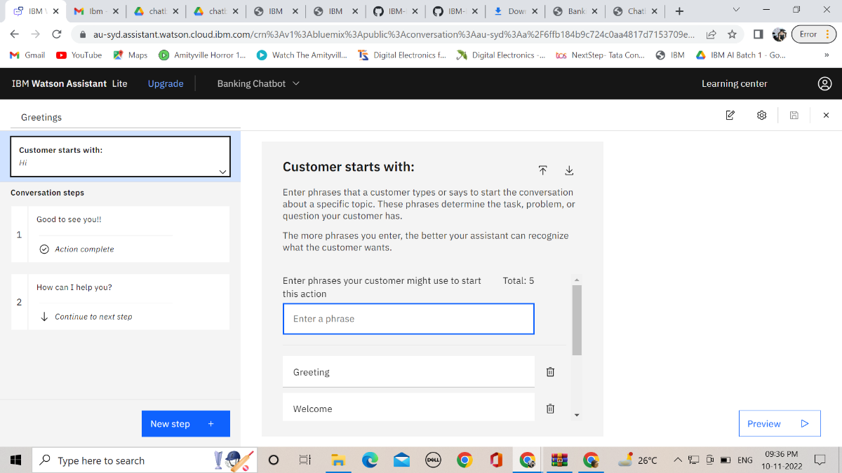

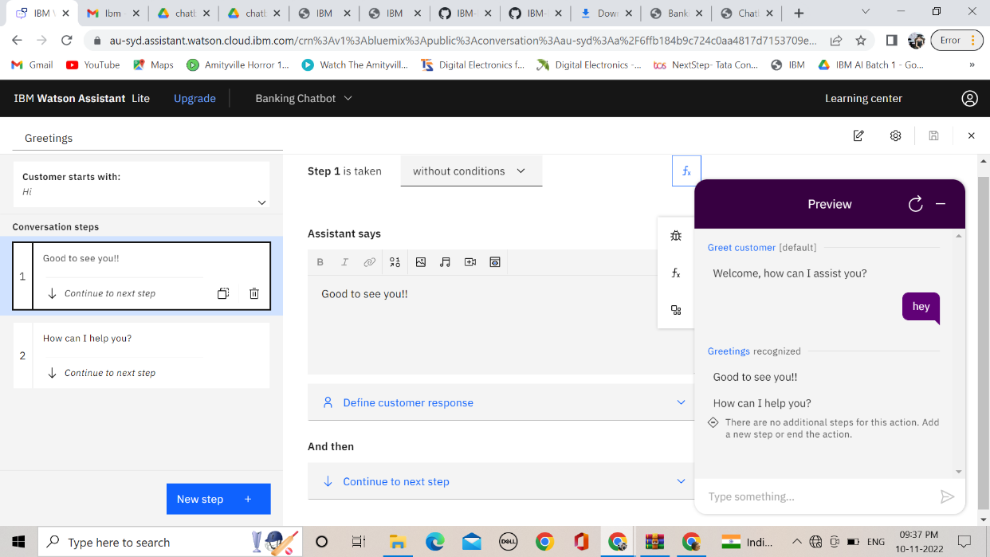

**Fall Back**

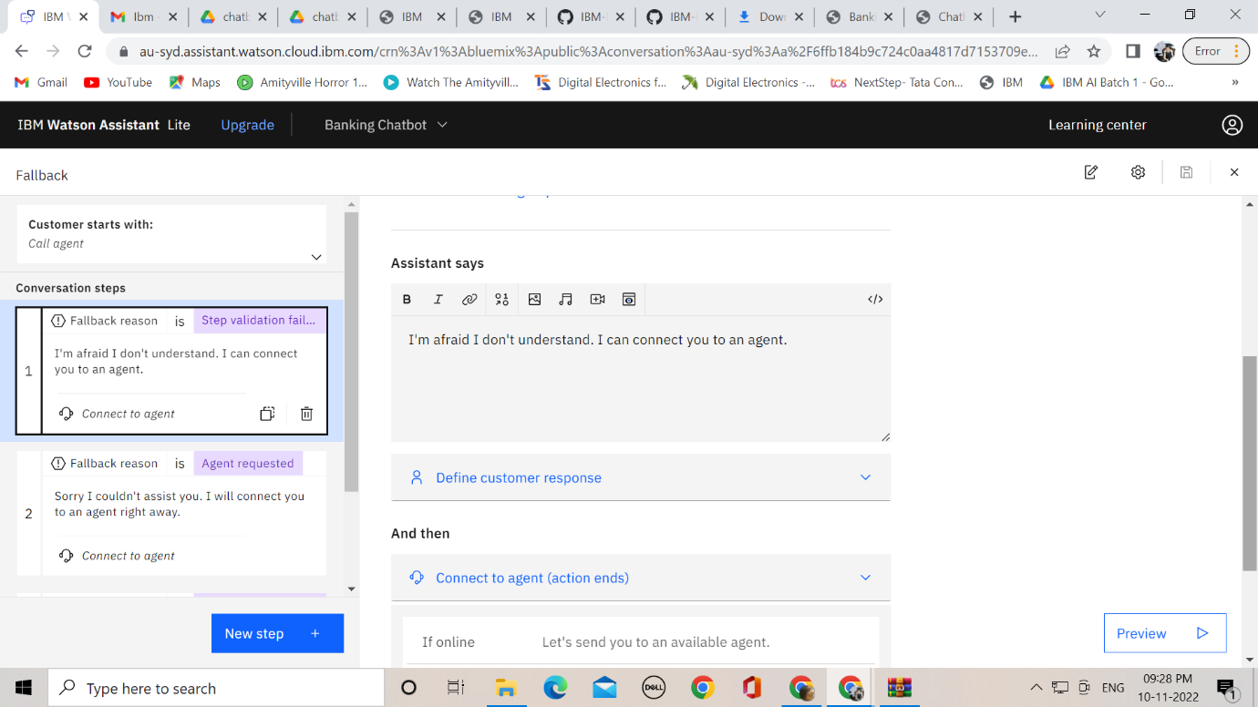

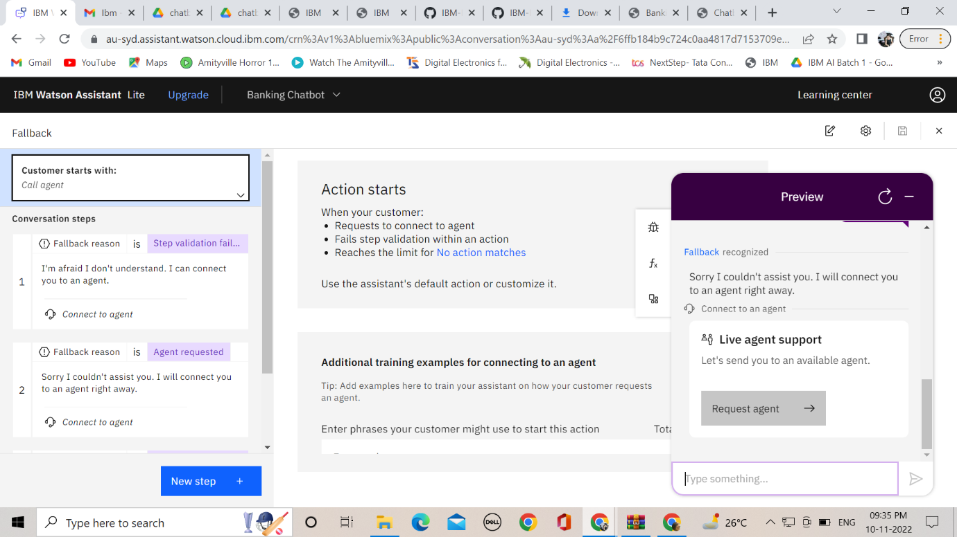

**End Greetings**

